

Sri Lanka Institute of Information Technology

[**Enterprise Standards and Best Practices for IT Infrastructure**](http://courseweb.sliit.lk/course/view.php?id=137)

**LAB 02**

**Creating Linux AMI instances using AWS**

**IT 130 699 64**

**Subhani K.G.D.**

**Weekday IT**

**14th July 2016**

Creating Linux Instance using AWS account.

1. First user has to login to the AWS account and then click “Launch Instance” button and from the list of AMI s appeared on the screen select “Amazon Linux AMI 2016.03.3 (HVM)” AMI to create linux instance.

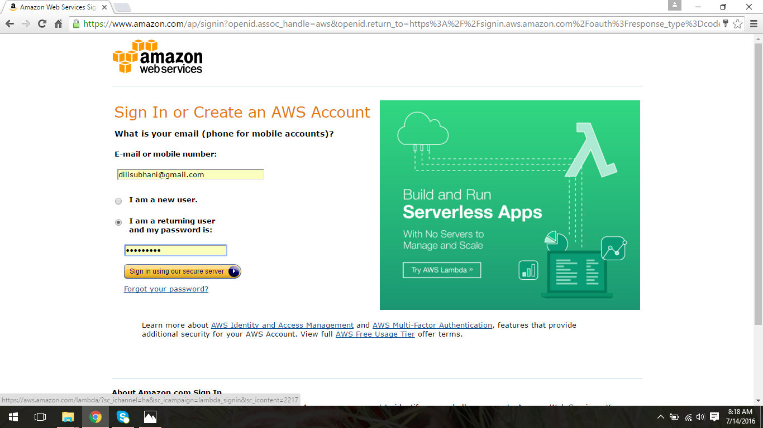

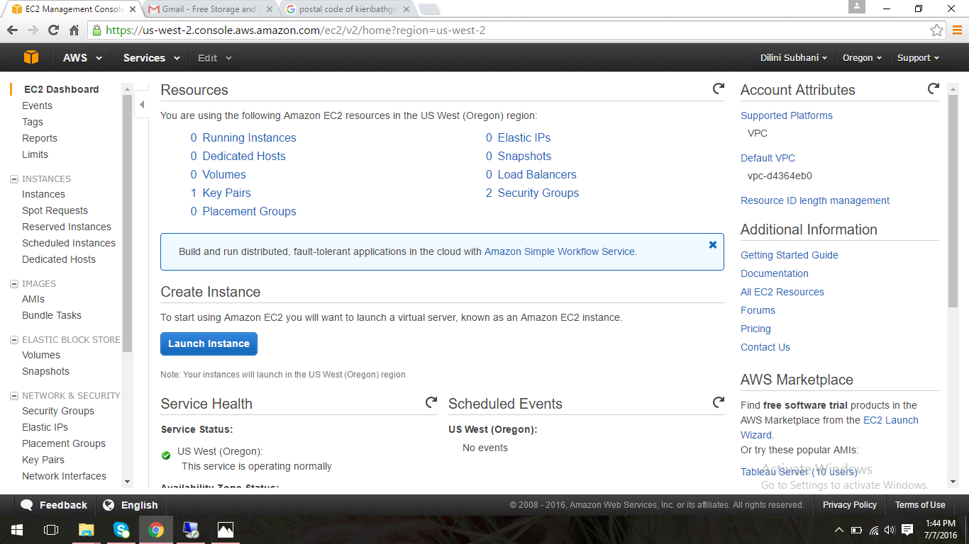

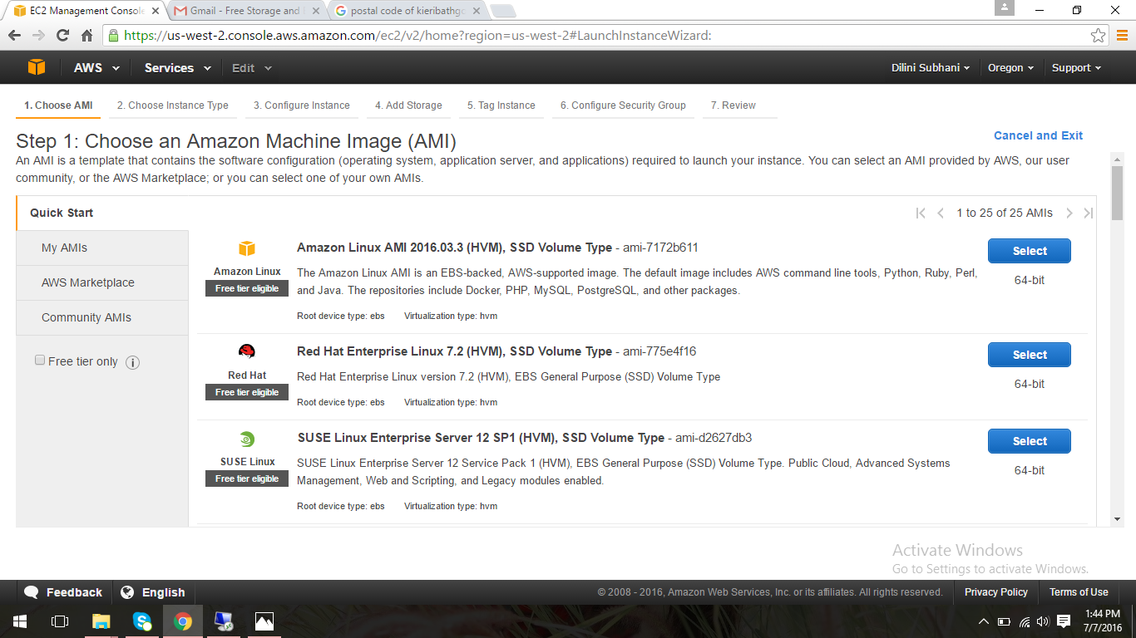

1. Select the default instance type given and click “Preview and Launch” button.

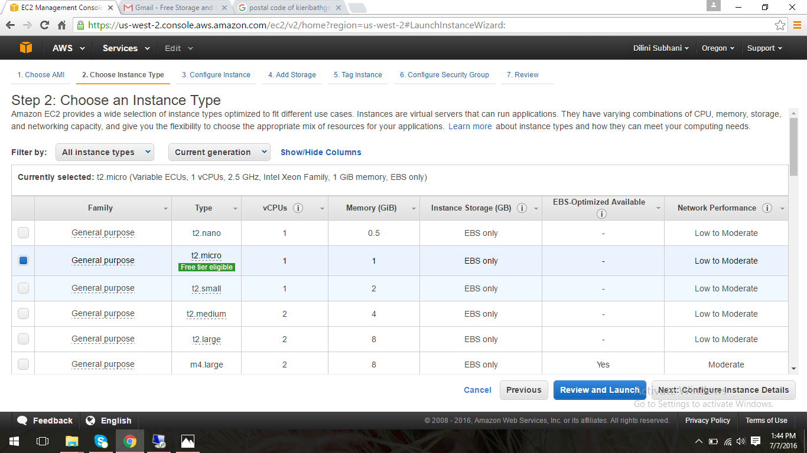

1. Then after creating the instance next step is reviewing the instance created. Click the “Launch” button to continue.

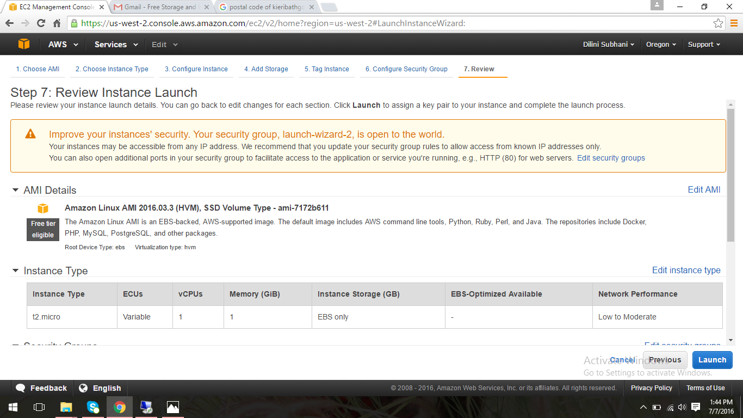

1. Next user has to create a new key pair to launch the newly created instance by providing a name to the key pair and then click “Download Key pair” button to download the key pair to your system and “dili_linux.pem” file will be downloaded.

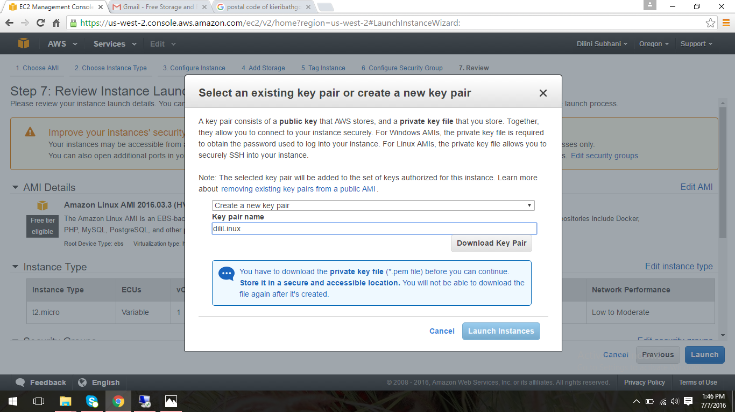

1. Then created instance will be launched as shown below and click the “View instance” button to view the instance you created.

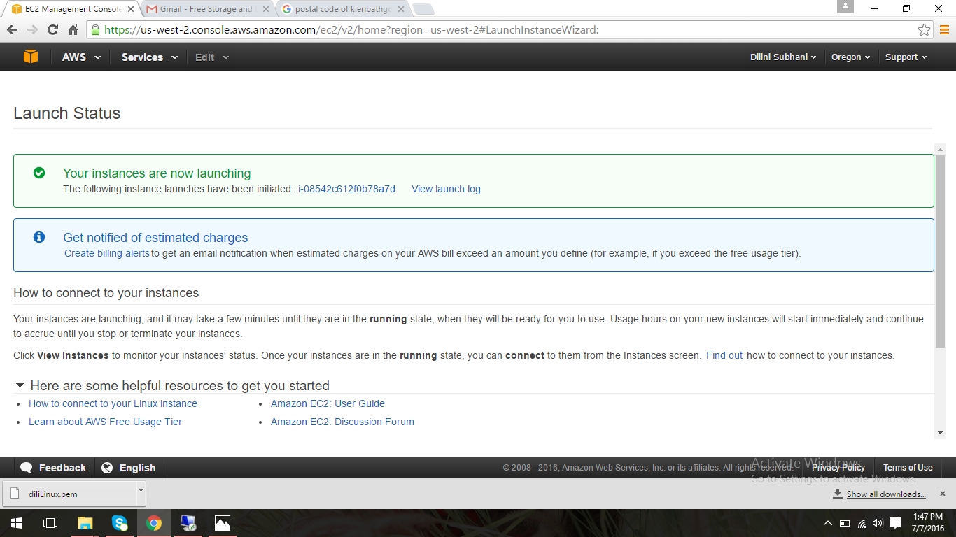

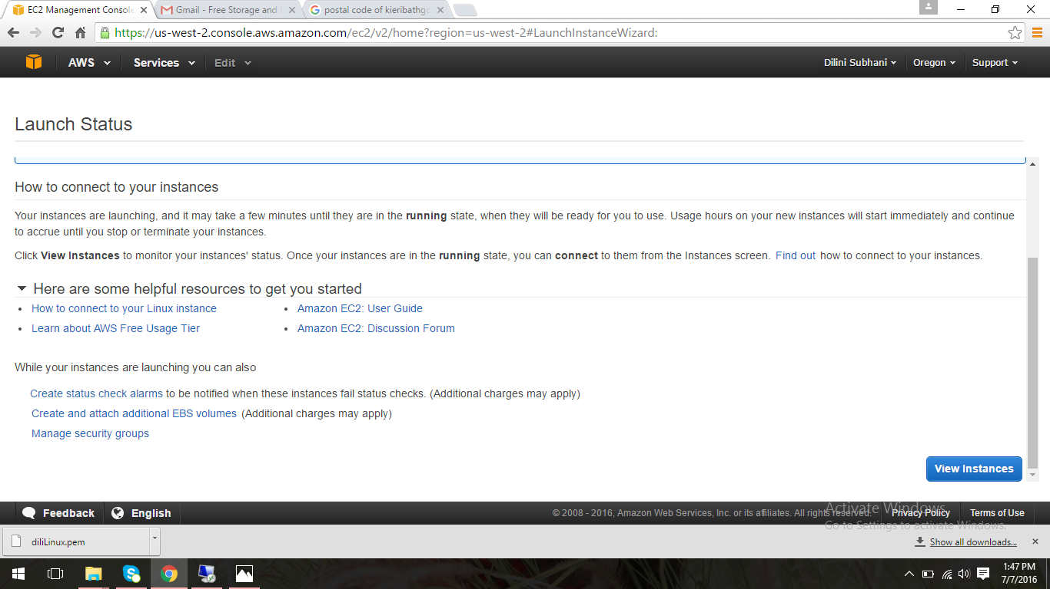

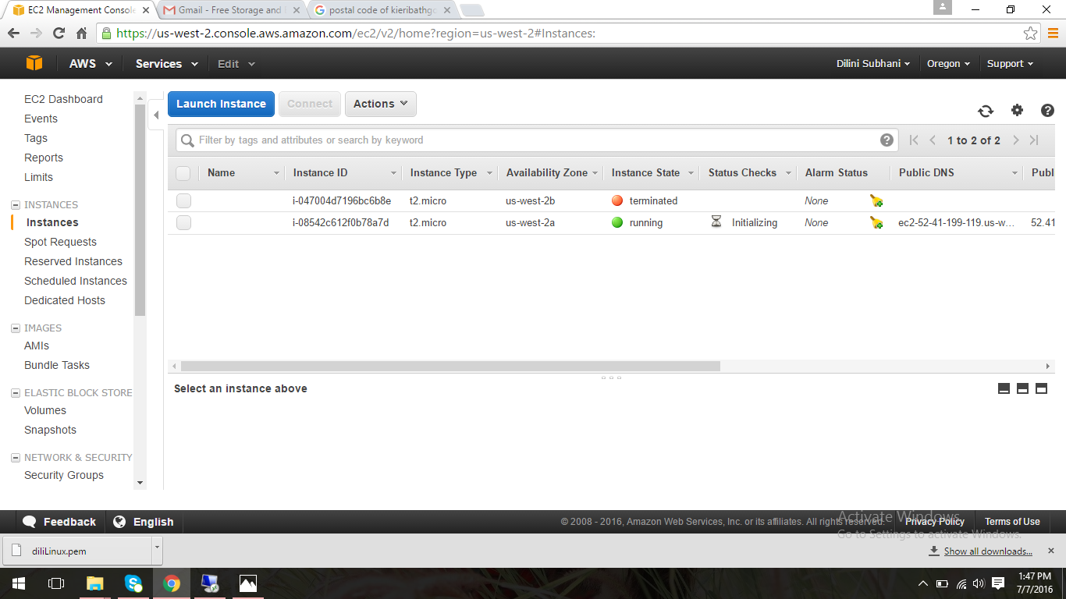

1. Then download putty.exe and puttygen.exe files.

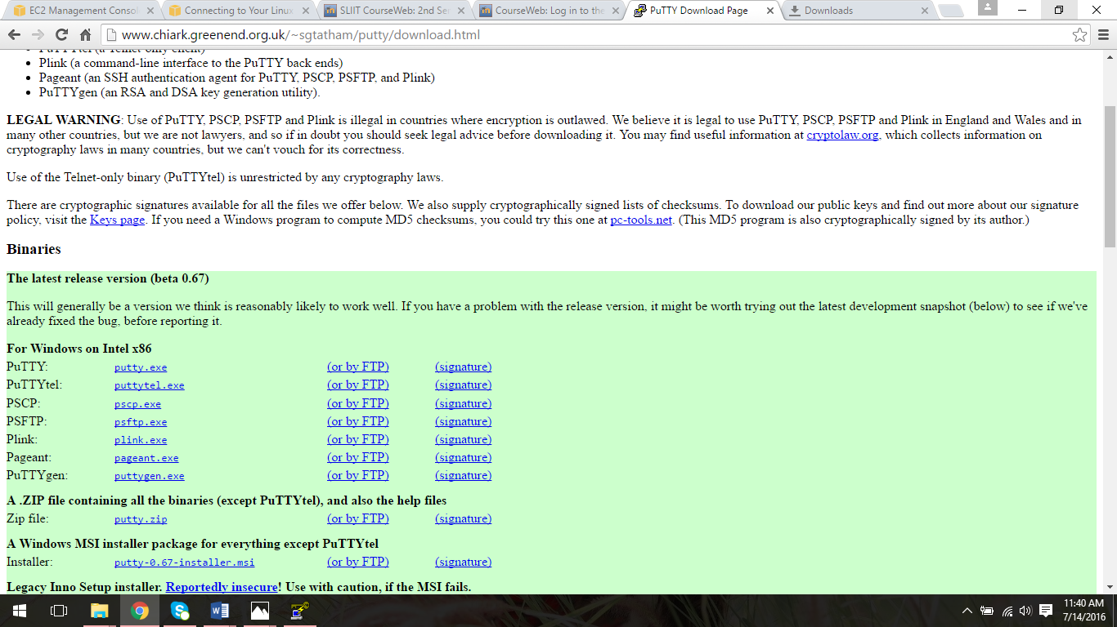

1. Next open the puttygen.exe file and click “Generate” button to get the putty key. Under type of key to generate, select SSH-2 RSA.

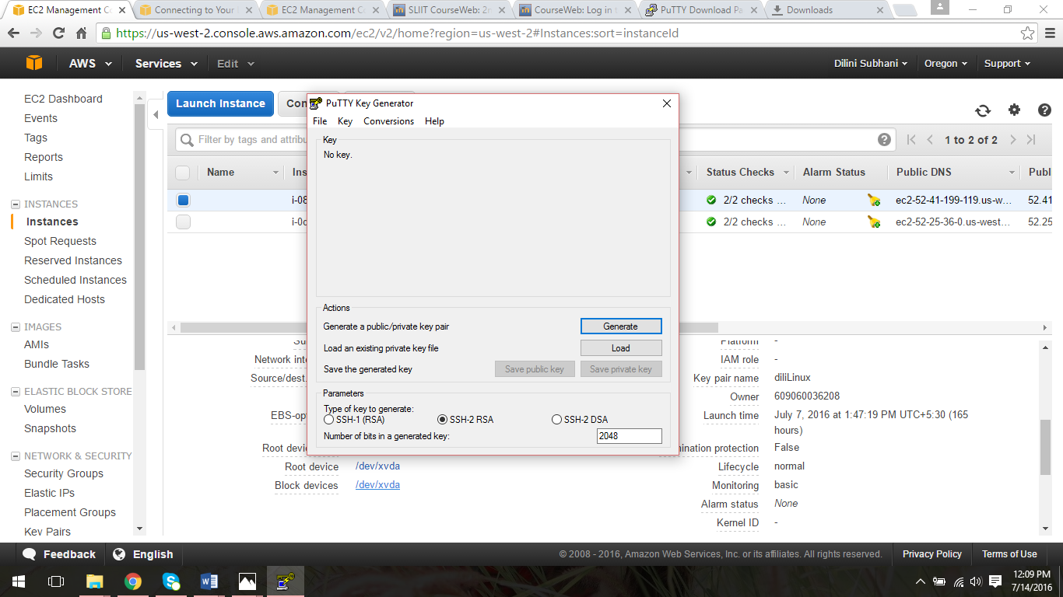

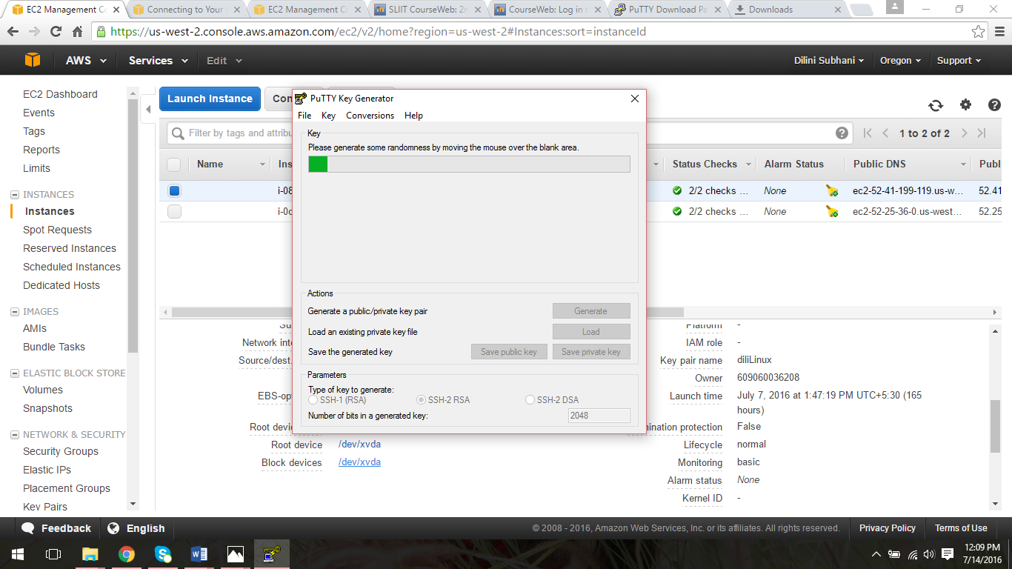

1. Click “Load” button and locate dili_linux.pem file and click “Open”.

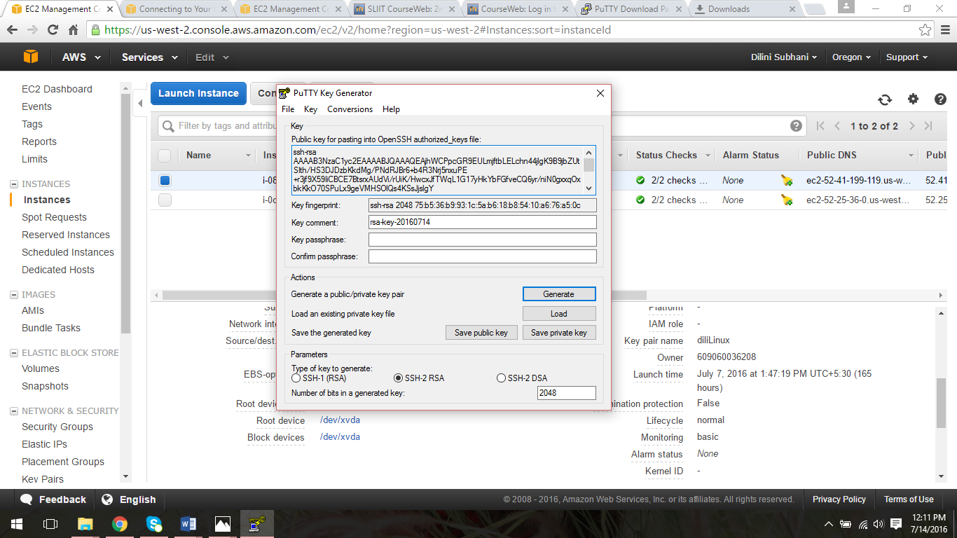

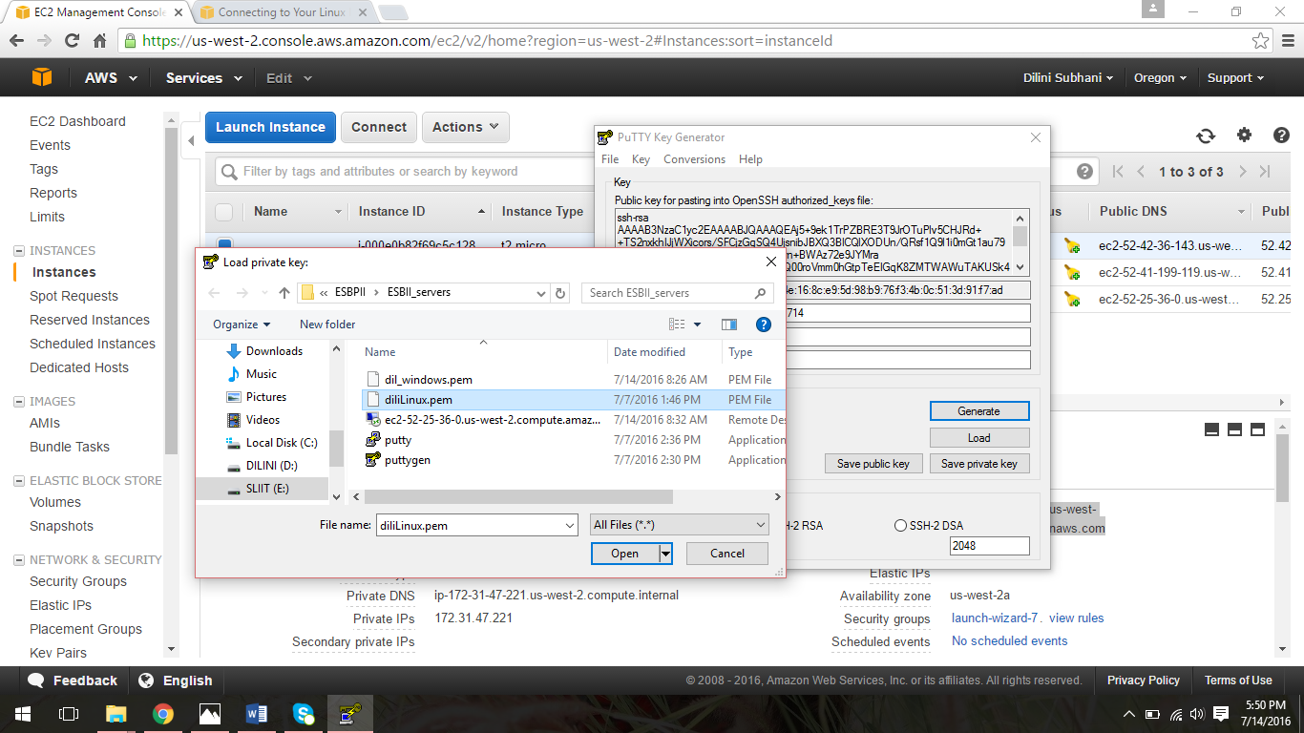

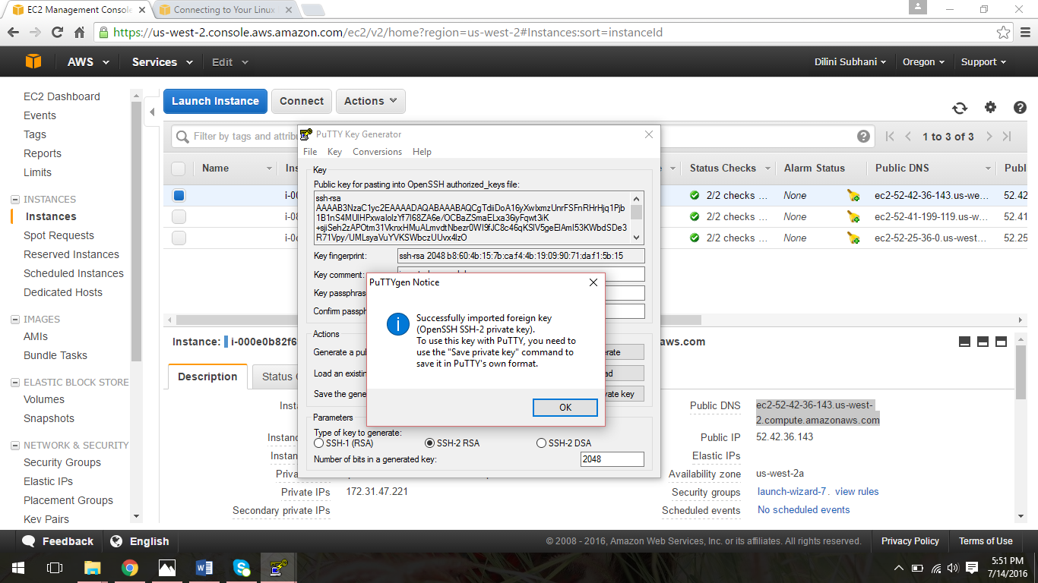

1. After generating the putty key it should be saved by clicking “Save Private Key” to use it in putty. Click “Yes” to continue and define the place where the putty key should be saved.

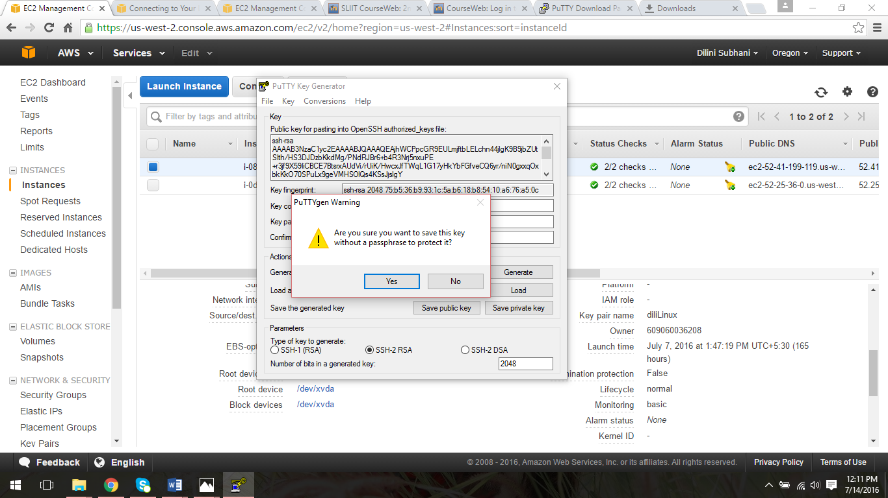

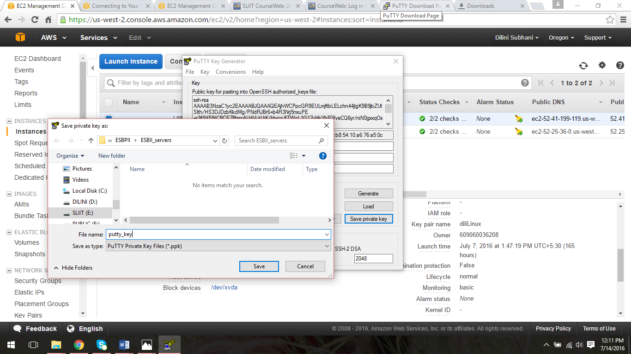

1. Then open the putty.exe file to connect to the linux instance and give the public DNS as hostname and provide a name to save the creating session and click “Save”.

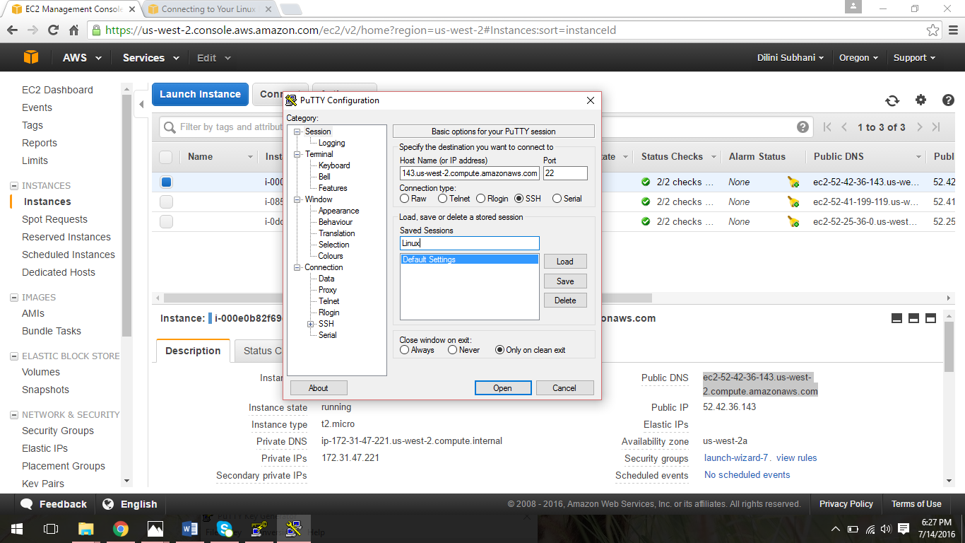

1. Then go to Connection- SSH – Auth to control SSH authentication.

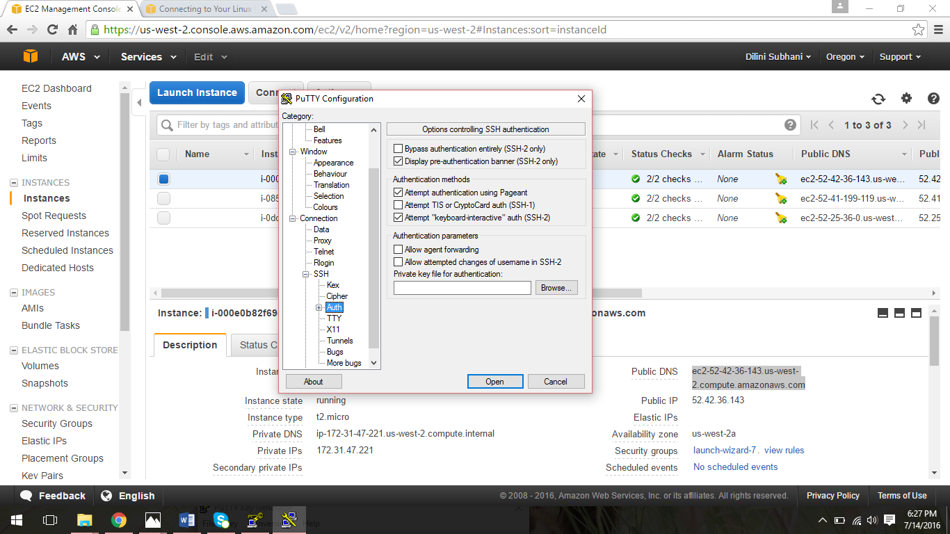

1. Then locate the saved private key to start the linux instance with putty.

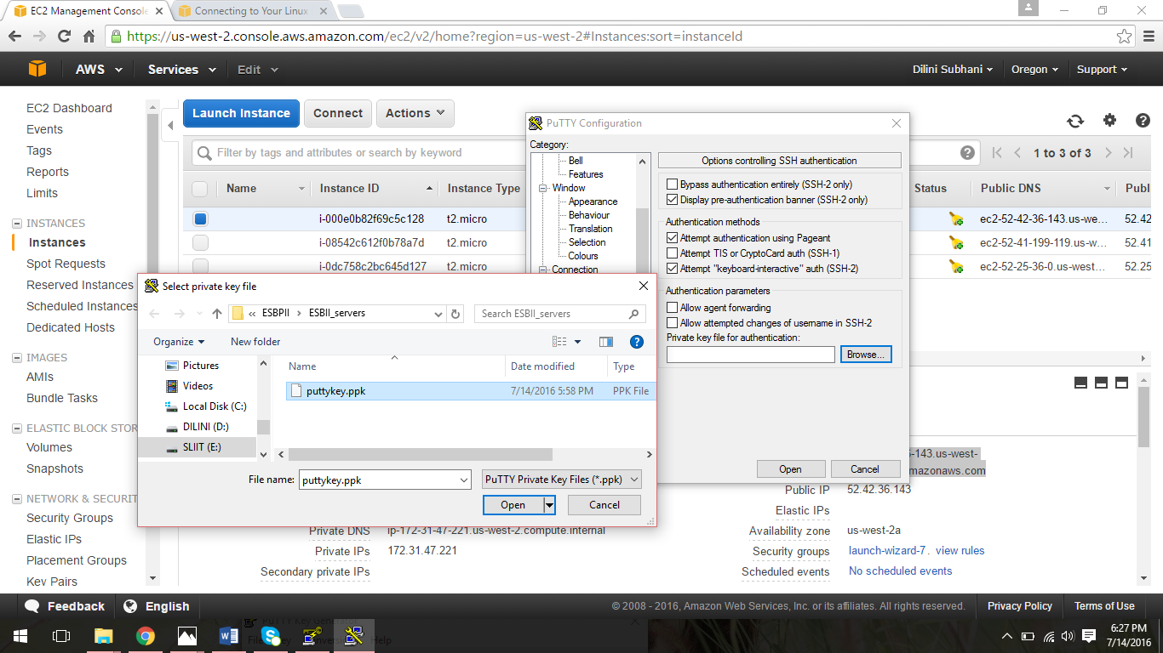

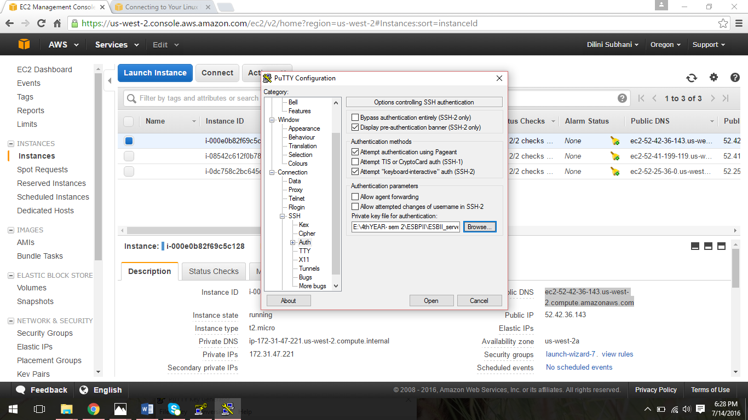

1. Then the console will appear and user has to login as “ec2-user” to launch the Linux AMI instance.

